**NOAA Global Surface Summary of the Day Weather Data**

Martin Hoffman

Chris Tordi

**The Data**

Our dataset “includes global data obtained from the USAF Climatology Center. This dataset covers GSOD data between 1929 and 2016, collected from over 9000 stations.” The data covers all pertinent meteorological information gathered by the stations including temperature, precipitation, visibility, dew point, etc.

**Licensing**

The information is freely accessible to all users through Google’s BigQuery console via SQL queries. “This dataset is publicly available for anyone to use under the following terms provided by the Dataset Source — <http://www.data.gov/privacy-policy#data_policy> — and is provided ‘AS IS’ without any warranty, express or implied, from Google. Google disclaims all liability for any damages, direct or indirect, resulting from the use of the dataset.”

**Link**

<https://cloud.google.com/bigquery/public-data/noaa-gsod>

**The Webapp**

1. State Weather Summary
   1. MVP: Highest/lowest temperature since 1929, average temperature by season (last 20 years)
   2. Stretch: Average rainy/snowy days, average rainfall/snowfall, average humidity by season
2. State comparison based on 1.
3. State suggestions based on user climate preferences
   1. MVP: Temperature, sunny days
   2. Stretch: Rainy days, snowy days, humidity
4. Refine to City-Level
5. Ambience: Spotify Integration

**Web Images**

**Home Page**

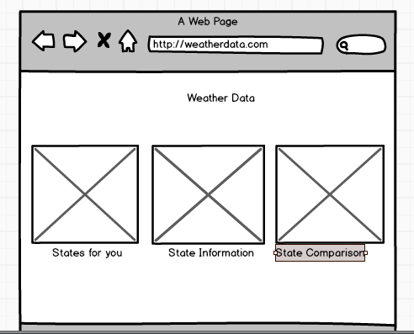

State Comparison

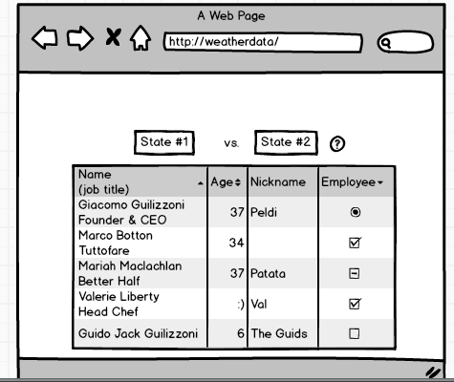

Ideal State Finder

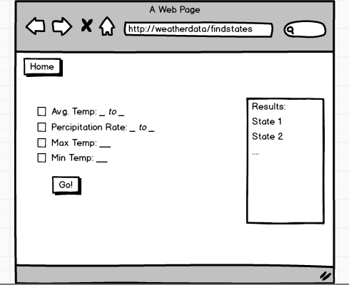

State Search

